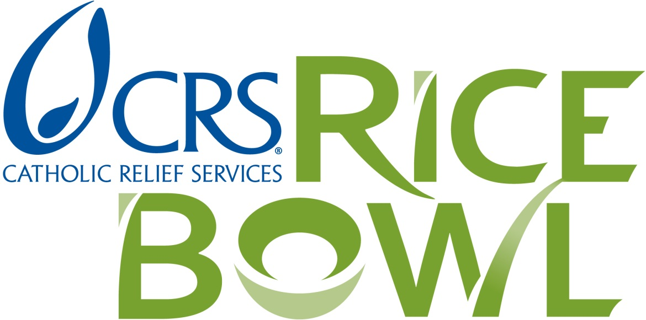

Recipients of the Matthew 25: CRS Rice Bowl Grant
2018
Cathedral Soup Kitchen (Ss. Peter and Paul Cathedral parish)
Catholic Charities - Terre Haute
God's Bounty Food Pantry (Nativity parish)
Irvington Community Advocacy Network (Our Lady of Lourdes is a member)
Our Lady of the Greenwood Food Pantry (OLG parish)
Samaritan Food Pantry – Terre Haute (St. Joseph University parish)
Society of St. Vincent de Paul – Brown County (St. Agnes parish)
Harvest Food Pantry (Ss. Francis and Clare parish)
St. Benedict Food Pantry – Terre Haute (St. Benedict parish)
St. Vincent de Paul Society of Shelby County (St. Joseph parish)
St. Patrick Soup Kitchen – Terre Haute (St. Patrick parish)

